EXPERIMENT ASSESSMENT
ACADEMIC YEAR 2025-26

Course: Multidisciplinary Minor

Course code: MDC401

Year: SE SEM: IV

Experiment No. 2
AIM: Design a landing page for a fictional product or service using HTML, CSS, and Bootstrap. Include a hero section, product descriptions, pricing plans, and a contact form. Make it mobile friendly with Bootstrap grid system.
Name: Ashish Ramesh Patel
Roll Number: 55
Date of Performance:
Date of Submission:

Evaluation
Performance Indicator | Max. Marks | Marks Obtained
Performance | 5
Understanding | 5
Journal work and timely submission. | 10
Total | 20

Performance Indicator | Exceed Expectations (EE) | Meet Expectations (ME) | Below Expectations (BE)
Performance | 5 | 3 | 2
Understanding | 5 | 3 | 2
Journal work and timely submission. | 10 | 8 | 4

Checked by

Name of Faculty : Dr. Yogesh Pingle

Aim: Design a landing page for a fictional product or service using HTML, CSS, and Bootstrap. Include a hero section, product descriptions, pricing plans, and a contact form. Make it mobile friendly with Bootstrap grid system.

Theory:

A landing page is a single, focused web page designed to present a product, service, or idea to users in a clear and visually appealing manner. The primary objective of a landing page is to capture user attention, communicate value effectively, and encourage a specific action such as sign-up, inquiry, or purchase. Landing pages are widely used in modern web development for marketing, product launches, and service promotion
HTML (HyperText Markup Language)
HTML is the standard markup language used to structure web content. It defines the layout and elements of a web page such as headings, paragraphs, images, links, forms, and sections. In a landing page, HTML is used to create key components like the hero section, product descriptions, pricing tables, and contact forms. Semantic HTML elements improve accessibility and search engine optimization.
CSS (Cascading Style Sheets)
CSS is used to control the visual presentation of HTML elements. It allows developers to apply styles such as colors, fonts, spacing, alignment, and layouts. In a landing page, CSS enhances the overall look and feel, ensures consistency in design, and improves user experience. Custom CSS can be used along with Bootstrap styles to achieve a unique and professional appearance
Bootstrap Framework
Bootstrap is an open-source front-end framework that simplifies responsive web design. It provides predefined CSS classes and JavaScript components that help in building modern, mobile-first websites quickly. Bootstrap includes ready-made components such as navigation bars, buttons, cards, forms, and pricing layouts which are commonly used in landing pages.
Hero Section
The hero section is the topmost part of a landing page and serves as the first visual interaction for users. It typically contains a prominent heading, a short description, and a call-to-action button. The hero section plays a crucial role in grabbing user attention and clearly communicating the purpose of the product or service.

Product Description Section
This section provides detailed information about the product or service, highlighting its features, benefits, and unique selling points. Clear and concise descriptions help users understand the value offered and build trust. Bootstrap cards and grid layouts are often used to present product information in a structured manner.

Pricing Plans
Pricing plans display the cost structure of the product or service in a transparent and organized format. This section commonly uses columns to compare different plans side by side. Bootstrap’s grid system enables easy alignment of pricing cards, making the section visually balanced and readable on all screen sizes.

Contact Form
A contact form allows users to communicate with the service provider. It typically includes input fields such as name, email, message, and a submit button. Bootstrap form classes ensure proper alignment, validation, and responsiveness, improving usability across devices.

Responsive Design Using Bootstrap Grid System
Responsive web design ensures that a web page adapts to different screen sizes such as desktops, tablets, and mobile phones. Bootstrap’s grid system is based on a 12-column layout that adjusts automatically according to screen width. By using grid classes like col-sm, col-md, and col-lg, developers can create mobile-friendly layouts without writing complex CSS.

Procedure
- Create index.html file.
- Add Bootstrap CDN in <head>:
- <link href="https://cdn.jsdelivr.net/npm/bootstrap@5.3.0/dist/css/bootstrap.min.css" rel="stylesheet">
- Create hero section:
- <div class="container text-center py-5">
<h1>My Product</h1>
<p>Amazing solution for modern problems</p>
</div>
- Add product cards using Bootstrap grid.
- Add pricing section using cards.
- Create contact form using Bootstrap forms.

Code:
Index.html
<!DOCTYPE html>
<html lang="en">
<head>
<meta charset="UTF-8">
<meta name="viewport" content="width=device-width, initial-scale=1.0">
<title>TitanArm | Desktop Automation</title>
<link href="https://cdn.jsdelivr.net/npm/bootstrap@5.3.0/dist/css/bootstrap.min.css" rel="stylesheet">
<link rel="stylesheet" href="https://cdnjs.cloudflare.com/ajax/libs/font-awesome/6.0.0/css/all.min.css">
<link rel="stylesheet" href="style.css">
</head>
<body>

<nav class="navbar navbar-expand-lg navbar-dark bg-dark sticky-top">
<div class="container">
<a class="navbar-brand fw-bold text-uppercase" href="index.html">Titan<span class="text-warning">Arm</span></a>
<button class="navbar-toggler" type="button" data-bs-toggle="collapse" data-bs-target="#navbarNav">
<span class="navbar-toggler-icon"></span>
</button>
<div class="collapse navbar-collapse" id="navbarNav">
<ul class="navbar-nav ms-auto">
<li class="nav-item"><a class="nav-link active" href="index.html">Overview</a></li>
<li class="nav-item"><a class="nav-link" href="specs.html">Tech Specs</a></li>
<li class="nav-item"><a class="nav-link" href="pricing.html">Kits</a></li>
<li class="nav-item"><a class="nav-link" href="contact.html">Contact</a></li>
</ul>
</div>
</div>
</nav>

<header class="hero-section d-flex align-items-center">
<div class="container">
<div class="row align-items-center">
<div class="col-lg-6">
<h1 class="display-3 fw-bold mb-4">Industrial Precision.<br>Desktop Scale.</h1>
<p class="lead mb-5 text-light opacity-75">The 6-axis mechanical arm that brings factory-grade automation to your workbench. 0.05mm repeatability for assembly, soldering, and 3D printing.</p>
<div class="d-flex gap-3">
<a href="specs.html" class="btn btn-warning btn-lg shadow">See How It Works</a>
<a href="pricing.html" class="btn btn-outline-light btn-lg">Buy Now</a>
</div>
</div>
<div class="col-lg-6 d-none d-lg-block text-center">
<img src="Titan_Render.png" class="img-fluid rounded-4 shadow-lg border border-warning border-3" alt="Titan Robotic Arm Render">
</div>
</div>
</div>
</header>

<section class="py-5 bg-white">
<div class="container">
<div class="text-center mb-5">
<h2 class="fw-bold">Why TitanArm?</h2>
<p class="text-muted">Solving the "Labor vs. Scale" problem for small businesses.</p>
</div>
<div class="row text-center g-4">
<div class="col-md-4">
<div class="p-4 border rounded-4 h-100 shadow-sm bg-light">
<div class="icon-box mb-3 text-warning">
<i class="fas fa-microchip fa-3x"></i>
</div>
<h4>Precision Tasks</h4>
<p class="text-muted">Automate repetitive PCBA soldering or gluing tasks that cause human fatigue with 0.05mm accuracy.</p>
</div>
</div>
<div class="col-md-4">
<div class="p-4 border rounded-4 h-100 shadow-sm bg-light">
<div class="icon-box mb-3 text-warning">
<i class="fas fa-cogs fa-3x"></i>
</div>
<h4>High Torque</h4>
<p class="text-muted">Custom planetary gearboxes provide enough lifting capacity (5kg) for heavy assembly work.</p>
</div>
</div>
<div class="col-md-4">
<div class="p-4 border rounded-4 h-100 shadow-sm bg-light">
<div class="icon-box mb-3 text-warning">
<i class="fas fa-code fa-3x"></i>
</div>
<h4>Open Source</h4>
<p class="text-muted">Program in Python, C++, or ROS. You own the hardware, you own the code. No subscriptions.</p>
</div>
</div>
</div>
</div>
</section>
<footer class="bg-dark text-white text-center py-4">
<p class="mb-0">&copy; 2024 Titan Robotics. Engineered for Builders.</p>
</footer>

<script src="https://cdn.jsdelivr.net/npm/bootstrap@5.3.0/dist/js/bootstrap.bundle.min.js"></script>
</body>
</html>

Output:



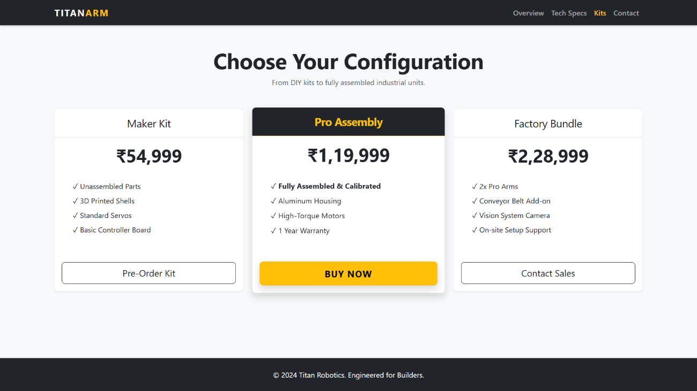
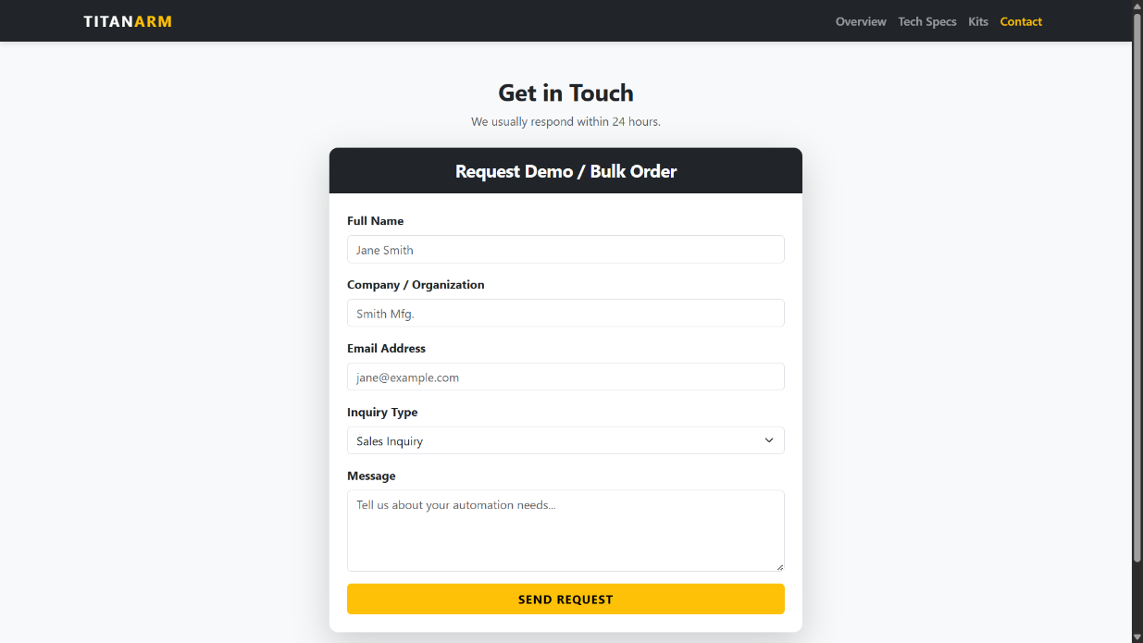

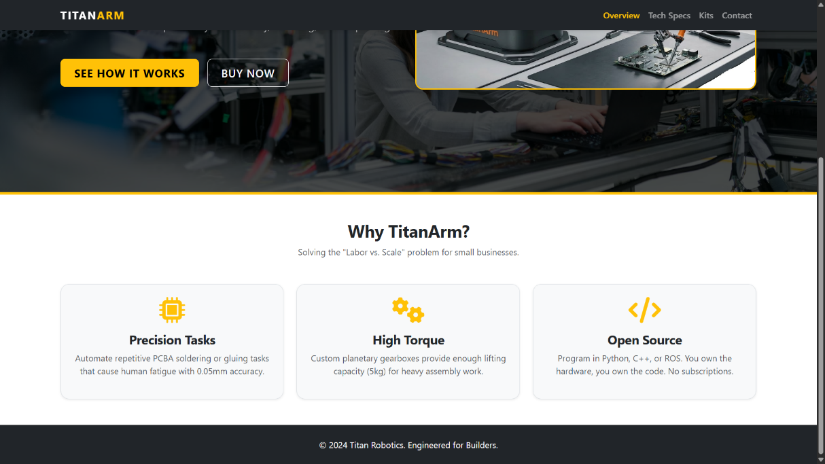

Conclusion:
Using HTML, CSS, and Bootstrap, a responsive and visually appealing landing page can be designed efficiently. Bootstrap simplifies layout management and ensures mobile friendliness, making it an ideal framework for modern web development.

Question:
- What is a landing page?
Ans:
Definition: A landing page is a standalone web page designed for a specific purpose, usually marketing or lead generation.
Key Points:
- Focused on a single product, service, or campaign.
- Contains a clear Call to Action (CTA) (e.g., sign-up, buy, download).
- Optimized for conversions rather than general browsing.

- How do you make images and videos responsive in Bootstrap?
Ans:
Definition: Responsiveness ensures media adjusts automatically to fit different screen sizes.
Key Points:
- Images: Use the class .img-fluid → makes images scale with parent container.
- Videos: Wrap videos in .embed-responsive and use .embed-responsive-item.
- Maintains aspect ratio and prevents overflow on smaller devices.

- What is the difference between margin and padding?
Ans:
Aspect | Margin | Padding
Definition | Space outside the element’s border | Space inside the element’s border
Purpose | Creates distance between elements | Creates space between content and border
Effect on Size | Does not increase element size | Increases element’s total size
Example | margin: 10px; → pushes element away | padding: 10px; → adds space inside element

